"Name" LLC

REGULATIONS
about the management system
occupational health and safety
(OHSMS)

2026
APPROVED:
By order of the director
"Name" LLC
from "__" ________ 2026
№ _____

REGULATIONS
on the occupational health and safety management system (OHSMS)

1. General provisions.
1.1. The Regulations on the Occupational Health and Safety Management System (hereinafter referred to as the Regulations) establish the procedure for the organization and operation of the occupational health and safety management system at Name LLC (hereinafter referred to as the Company).
1.2. The requirements of these Regulations are mandatory for all employees of the enterprise.
1.3. The occupational health and safety management system (OHSMS) is a part of the general management system of the enterprise, which contributes to the prevention of accidents and occupational diseases at work, as well as dangers to third parties arising in the business process, and includes a set of interrelated measures to fulfill the requirements of legislative and other occupational health and safety laws and regulations.
1.4. These Regulations shall apply insofar as they do not conflict with applicable Ukrainian law.
1.5. The regulation was developed taking into account the requirements of the following regulatory documents:
- the Law of Ukraine "On occupational health and safety";
- the Code of Labor Laws of Ukraine;
- the Law of Ukraine "On mandatory state social insurance";
- Recommendations on the construction, implementation and improvement of the occupational health and safety management system, approved by the Chairman of Derzhhirpromnadzor S. Storchak dated October 13, 2026;
- other occupational health and safety laws and regulations.
1.6. The goal of occupational health and safety management is to implement the constitutional rights of employees and ensure the requirements of regulatory acts regarding the preservation of health and working capacity of a person during work, the creation of safe and harmless working conditions, as well as conditions under which not only the timely elimination of any violations of occupational health and safety norms, but also the prevention of their occurrence are ensured.
1.7. The object of occupational health and safety management is the conditions and state of occupational health and safety at workplaces.
1.8. Organizational and methodological work on occupational health and safety management, organization and control over the operation of the OHSMS are carried out by the head of the enterprise and specialists of the Occupational Health and Safety Service of the enterprise.
1.9. Public control over compliance with the requirements of these Regulations is carried out by the workforce of the enterprise through the persons authorized by it in the field of occupational health and safety.
1.10. Briefly, the current OHSMS can be described as follows:
Plan - Do - Check - Act
- Plan: establish goals and processes that should produce results in accordance with the organization's health and safety policy.
- Do: implement the developed processes in the day-to-day activities of the enterprise.
- Check: Monitor and measure processes against health and safety policies, objectives, targets, legislative and other requirements, and report results.
- Action: Implement actions to continuously improve performance.
1.11. The occupational health and safety management system must be compatible or combined with other management systems in the organization:

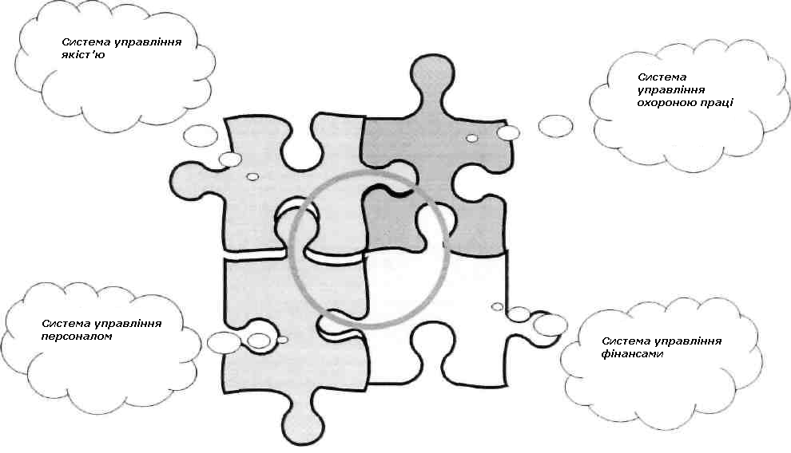

2. Basic principles of policy in the field of occupational health and safety.
2.1. The company's policy in the field of occupational health and safety is aimed at creating proper, safe and healthy working conditions, preventing accidents and occupational diseases.
2.2. The main principles on which the company's policy is based are as follows:
- recognizing and ensuring the priority of the life and health of employees in relation to the results of economic activity, the full responsibility of the top management for the creation of proper, safe and healthy working conditions;
- management complexity and coordination of activities of all management entities in order to solve occupational health and safety tasks;
- carrying out business activities in accordance with the requirements of legislative and other occupational health and safety laws and regulations;
- identification of all dangerous and harmful production factors present at workplaces, their comprehensive assessment and implementation of measures to reduce their impact on employees;
- constant improvement of the SUOP, which allows to minimize the risks of accidents, occupational diseases and accidents in the course of economic activity;
- use of economic methods of occupational health and safety management, financing of necessary occupational health and safety measures;
- involvement of employees in active participation in creating and ensuring healthy and safe working conditions;
- conducting training, professional training and advanced training of employees on occupational health and safety issues;
- informing interested parties about occupational health and safety indicators, risks of accidents, occupational diseases and accidents;
- using the best global practices to improve the operation of the SWMS.

3. Planning and financing of occupational health and safety measures.
3.1. Work on occupational health and safety is carried out in accordance with long-term and current plans, which define local and strategic directions for the improvement of OHSMS, aimed at: improving working conditions, maintaining the efficiency of production equipment, implementing and improving engineering and technical safety equipment, sanitary and household maintenance, etc.
3.2. The planning of occupational health and safety works is carried out by:
- at the level of the enterprise as a whole - Occupational Health and Safety Service;
- at the unit level - the head of the structural unit.
3.3. The planning of occupational health and safety works is carried out on the basis of:
- comprehensive measures to achieve the established standards and increase the existing level of occupational health and safety;
- execution of binding instructions issued by state supervisory authorities implementing state policy in the field of occupational health and safety;
- measures to improve working conditions and safety, proposed by state supervision bodies, the Occupational Health and Safety Service, employee representatives for occupational health and safety, etc.;
- proposals for improving working conditions and safety from the heads of structural units and employees of the enterprise;
- measures to eliminate deficiencies identified during the investigation of accidents and accidents;
- available financial capabilities of the enterprise.
3.4. Financing of occupational health and safety measures is carried out at the expense of funds that must be allocated to the occupational health and safety fund in an amount not lower than that established by the current legislation of Ukraine.

4. The main tasks of the OHSMS and methods of solving them.
4.1. The main task of the OHSMS is to systematize the occupational health and safety work carried out at the enterprise, to increase its effectiveness and efficiency through the rational and planned use of the available technical, organizational and economic capabilities of the enterprise.
4.2. At each level of occupational health and safety management, the following main tasks are solved:
- carry out business activities in accordance with the requirements of the current legislation of Ukraine in the field of occupational health and safety;
- to contribute to the reduction of risks based on the constant identification of hazards, assessment and control of risks;
- to provide workers with the necessary collective and personal protective equipment, as well as to introduce new and modern collective and personal protective equipment for more effective protection of workers;
- to increase the professional level and knowledge of the company's personnel in the field of occupational health and safety by conducting appropriate training and briefings;
- plan and implement organizational and technical measures aimed at ensuring the safe operation of production equipment, improving the working conditions of employees;
- to contribute to raising the level of occupational health and safety culture;
- to improve the technology of work and processes in order to exclude or reduce the effect on workers of dangerous and harmful production factors;
- to provide optimal modes of work and rest for employees.
4.3. To solve these problems, the following actions are expected:
- establishment of a unified procedure for planning, organization and coordination of occupational health and safety work;
- formation of the organizational structure of occupational health and safety management, appointment of responsible persons and determination of their duties;
- organization of control over working conditions and safety, the level of production safety;
- organization of control over employees' compliance with rules, regulations and instructions on occupational health and safety, rules for operating machines, mechanisms, equipment and other means of production, use of collective and individual protection, performance of work in accordance with the requirements of current occupational health and safety regulations;
- organization of information collection on the actual state of occupational health and safety, its accounting, analysis and assessment according to established indicators;
- systematic informing of the company's employees about the actual state of working conditions at workplaces, about the causes of accidents, accidents and occupational diseases;
- the use of economic methods to increase the interest of employees in maintaining the proper state of occupational health and safety, compliance with the requirements of rules, regulations and instructions on occupational health and safety, implementation of safe work methods, increasing the effectiveness of the operation of the OHSMS at the enterprise;
- taking appropriate influence measures aimed at increasing the personal responsibility of officials for organizing and ensuring occupational health and safety, and other employees for compliance with the requirements of occupational health and safety laws and regulations.

5. Management of occupational health and safety.
5.1. The organizational structure of the SUOP is formed on the basis of the current organizational structure of the enterprise and is subject to all the management principles inherent in it.
5.2. occupational health and safety management is carried out by:
- in general - the head of the enterprise;
- in a structural unit - the head of a structural unit;
- at the workplace - the direct supervisor of the works.
5.3. Organizational and methodical management of the enterprise's occupational health and safety activities, preparation of management decisions, coordination of activities to ensure healthy and safe working conditions, and control over compliance with legislative and other occupational health and safety laws and regulations are carried out by the enterprise's Occupational Health and Safety Service.
5.4. Representatives of the trade union committee or an authorized representative of the workforce on occupational health and safety issues participate in the management of occupational health and safety and health (if they are available).
5.5. At each level of the enterprise's organizational structure, tasks of occupational health and safety management are implemented using typical elements of the management cycle of planning, organization, stimulation, control, analysis and evaluation, etc.

6. Organization of control over the state of occupational health and safety.
6.1. The main types of control over the state of occupational health and safety at the enterprise are:
- control by the top management of the enterprise;
- control by the Occupational Health and Safety Service of the enterprise;
- day-to-day control by heads of structural divisions and responsible persons of the enterprise;
- control by representatives of the trade union committee or a person authorized by the workforce in matters of occupational health and safety (if they are available);
- supervision and control on the part of the central executive authorities implementing state policy in the field of occupational health and safety.
6.2. Control over the state of occupational health and safety by the top management of the enterprise consists in the analysis of the reports of the Occupational Health and Safety Service of the enterprise regarding the state of occupational health and safety at the enterprise, as well as periodic personal control of the state of occupational health and safety at the enterprise during a comprehensive inspection, which is carried out twice a year with the participation of the heads of the main services of the enterprise.
6.3. Control over the state of occupational health and safety by the Occupational Health and Safety Service of the enterprise consists of periodic inspections of the structural units of the enterprise by a specialist of the Occupational Health and Safety Service with the participation of the managers of these structural units. Elimination of detected violations of the requirements of rules and occupational health and safety regulations must be carried out immediately. In case of detection of a violation that may harm the health or life of workers or lead to an accident, work is stopped until this violation is eliminated. Based on the results of the inspection, an inspection report is drawn up, which is signed by an Occupational Health and Safety Service specialist and the head of the inspected structural unit.
6.4. Control by the managers of the company's structural divisions and persons responsible for the organization and safe execution of work is carried out daily during the work shift.
At the same time, it is checked:
- the state and correctness of the organization of workplaces (location and availability of the necessary means of protection and automation, protective fences, etc.);
- safety of technological equipment;
- compliance by employees with the requirements of occupational health and safety instructions;
- availability and correct use of individual and collective protective equipment by employees.
6.5. Control by representatives of the trade union committee (a person authorized by the workforce on occupational health and safety issues) is carried out in accordance with the "Regulations on public inspectors on occupational health and safety issues" ("Regulations on the activities of employee representatives for occupational health and safety"), which is approved at the general meeting of the workforce of the enterprise.
6.6. Supervision and control by central executive bodies implementing state policy in the field of occupational health and safety is carried out in accordance with the Law of Ukraine "On the Basic Principles of State Supervision (Control) in the Field of Economic Activity".

7. Liability.
7.1. For violation of the requirements of occupational health and safety legislation, the guilty persons may be brought to material, disciplinary, administrative and criminal liability in accordance with the current legislation of Ukraine.

8. Final provisions
8.1. These Regulations shall enter into force from the date of its approval by order of the enterprise.
8.2. Changes and additions to the Regulation are made by the relevant order of the enterprise. In the same order, the Regulation is repealed.

DEVELOPED BY:
Occupational Health and Safety Engineer ____________ Initials, Surname
(signature)

