Name LLC

Instruction No. 27
on occupational health and safety
when slinging loads

2026

APPROVED:
By order of the director
Name LLC
from "__" _________ 2026
№ _____

INSTRUCTION NO. 27
on occupational health and safety during cargo slinging

1. General provisions.
1.1. The instruction was developed in accordance with NPAOP 0.00-4.15-98 "Regulations on the development of instructions on occupational health and safety" and NPAOP 0.00-6.03-93 "Procedure for development and approval by the employer of regulatory acts on occupational health and safety".
1.2. The effect of this instruction applies to all employees who perform slinging work at the facilities of "Nazva" LLC (hereinafter - the company).
1.3. Slinging is a set of methods of preparing goods for lifting, transporting and transshipment work, tying and hooking them for lifting and moving with lifting equipment. Slinging is carried out with the help of permanent or removable load-handling devices, which are hung on the hook of the load-lifting device (sling, traverse, grabs, etc.).
1.4. Persons at least 18 years of age (hereinafter referred to as slingers) who have passed a medical examination (if necessary) and have no contraindications, appropriate training in safe methods of carrying out slinging works and have a certificate of the right to perform them, have passed induction and initial workplace briefings on occupational health and safety issues are allowed to strap, hook or hang loads.
Before starting work related to the operation of electrical equipment, the employee must undergo training to obtain the I electrical safety group.
1.5. Slingers must undergo refresher briefing on occupational health and safety once every 3 months, and when performing one-off work not directly related to their duties in the specialty, task-specific briefing on occupational health and safety in accordance with the nature of the work performed.
1.6. Slingers must once a year undergo training and check their knowledge of the relevant regulatory acts on occupational health and safety.
1.7. The slinger must:
- perform only the work that is prescribed by his work instructions or assigned to him by his manager;
- comply with the rules of internal labor regulations;
- take care of personal safety and health, as well as the safety and health of the surrounding people in the process of performing any work or while staying on the territory of the enterprise;
- have a concept of the structure of the lifting crane and know its load capacity;
- to know schemes of safe slinging of cargo, types of knots for tying it;
- be able to select slings necessary for work (in terms of carrying capacity, number of branches, length and angle of inclination of the branches of the sling to the vertical) and other load-handling devices depending on the mass and nature of the transported cargo;
- be able to determine the suitability of slings and other removable load-holding devices and containers;
- to be able to carry out the correct strapping and hanging of cargo on a hook;
- know the rules for filling containers;
- to know the order and dimensions of cargo storage;
- to know and comply with the requirements of fire safety rules, to know the locations of primary fire extinguishing equipment and to be able to use them;
- to know and comply with the requirements of normative legal acts on occupational health and safety and fire safety, the requirements of occupational hygiene standards and rules, to be able to provide first aid;
- use the provided collective and personal protective equipment.
1.8. The employee is provided free of charge with overalls, safety footwear and other personal protective equipment (PPE) in accordance with the current Standard Industry Norms or norms stipulated in the Collective Agreement.
1.9. The main harmful and dangerous production factors, which under certain circumstances can lead to injuries or occupational diseases, are as follows:
- moving machines and mechanisms; moving parts of production equipment;
- increased dustiness and gassiness of the air in the working area;
- increased or decreased air temperature of the working area;
- increased noise level at the workplace;
- increased level of vibration;
- increased value of the voltage in the electrical circuit, the circuit of which can occur through the human body;
- insufficient lighting of the working area;
- sharp edges, burrs and roughness on the surfaces of workpieces, tools and equipment;
- increased physical activity;
- increased neuro-emotional stress.
1.10. Detachable load-handling devices (slings, clamps, grabs, traverses, grapples, electromagnets, etc.) and their components must meet the requirements of regulatory documents (ND), and their design must exclude the possibility of arbitrary disconnection of the load.
1.11. Slings are intended for tying and hanging solid loads on a crane hook. They must meet the following requirements:
- manufactured slings must be provided with a stamp or a firmly attached metal tag indicating the number, load capacity and test date;
- for steel wire rope slings, steel wire ropes with a cross twist should be used. The ends of the ropes of the slings are laid by pressing with aluminum bushings, crimping with steel bushings or braiding;
- round-link chains should be used for chain slings;
- braiding a loop of hemp, cotton, sisal rope should have at least two full and two half punches. The place of braiding should be wrapped with a rope or protected in another way.
1.12. Containers, as a rule, are used to move and load loose cargo. The container must have plates or inscriptions indicating the inventory number, date of manufacture, load capacity, its own weight and purpose.
1.13. During operation, removable load-handling devices and containers are subject to periodic and daily inspection.
Periodic inspection of removable load-handling devices is carried out by the person responsible for maintaining the load-lifting cranes in good condition, in the following terms:
- slings - every 10 days;
- electromagnets, grapples - monthly;
- tare - monthly;
- removable cargo lifting devices that are rarely used - before each release for work (classification of cargo lifting devices as rarely used is carried out by the employee responsible for maintaining cargo lifting cranes in good condition, which must be recorded in the log of cargo lifting devices).
Daily inspection of removable load-handling devices is carried out by slingers immediately before their use.
1.14. An employee has the right to refuse work if the conditions of its performance pose a threat to his health or life or contradict the requirements of occupational health and safety regulations.
1.15. For violation of the requirements of this instruction, the employee bears administrative, disciplinary and criminal liability in accordance with the current legislation of Ukraine.
1.16. When carrying out cargo slinging work, the workers who perform them (slingers) must be guided by and comply with the requirements of the Instructions for the safe conduct of work for slingers (hookers), given in Appendix D of this instruction.

2. Safety requirements before starting work.
2.1. Before starting work, the employee must:
- put on and put in order the work clothes, safety footwear and PPE provided for the work;
- get a list of loads to be moved, indicating their weight and slinging scheme;
- check the condition of the workplace; if the floor is slippery, it must be wiped, sprinkled with sand or sawdust;
- choose load-handling devices that will correspond to the mass and nature of the load being lifted (slings should be selected taking into account the number of branches and their length so that the angle between the branches does not exceed 90°);
- conduct an inspection of the removable load-handling devices that will be used in the work, check their serviceability and the presence of appropriate stamps or marks on them;
- check the workplace lighting; in case of insufficient lighting, report this to the immediate supervisor.
2.2. If a threat to the safe conduct of work is detected, it is necessary to report it to the immediate supervisor and not to start work. It is allowed to start work only after the identified deficiencies have been eliminated.
2.3. Inspection of removable load-handling devices and containers should be carried out in accordance with the instructions specified in Appendix B to this instruction.

3. Safety requirements during work.
3.1. The slinger is allowed to start work only after receiving the task and instructions from the person who is responsible for the safe execution of work on the movement of cargo.
3.2. The following safety requirements should be observed when tying and securing cargo:
- strapping or hitching of cargo should be performed in accordance with cargo slinging schemes. Slinging of loads that are lifted and moved rarely, and for which slinging schemes have not been developed, should be carried out under the guidance of the person responsible for the safe performance of work on moving the load;
- check the weight of the cargo to be moved according to the cargo list or the marking on the cargo. If the slinger does not have the opportunity to determine the weight of the load, he must find out about it from the person responsible for the safe carrying out of the work on the movement of the load;
- when tying the load, ropes (or chains) should be applied to its main array (frame, frame, body, etc.) without knots, twists and loops. Special pads must be placed under the edges of the load to protect the slings from damage;
- the load should be tied in such a way that during its movement, the fall of its individual parts is excluded and the stable position of the load itself is ensured, for which the slinging of long loads should be carried out in no less than two places (example ways of tying loads are given in Appendix A of this instruction);
- hitching of loads equipped with hinges, frames, trunnions should be carried out by all hinges, frames, trunnions provided for lifting in the appropriate position;
- the ends of the multi-branch sling not used for hooking the load should be fixed in such a way that when the load is moved by the crane, the possibility of these ends hooking objects encountered on the way of movement is excluded;
- make sure that the load intended for lifting is not blocked by anything (not fixed, not pinched, not collapsed, not frozen to the ground, etc.).
3.3. When carrying out slinging work, the following rules must be observed:
- be attentive while working;
- not to be distracted during work and not to distract other employees;
- do not allow persons who are not related to this work to their workplace.
3.4. When tying and securing loads, the slinger is prohibited from:
- carry out slinging of cargo, the weight of which is unknown or exceeds the load-carrying capacity of the crane;
- use removable load-handling devices and home-made containers that are not marked, not tested or with an expired test date;
- connect links of broken chains with bolts or wire, tie ropes;
- carry out lashing and hitching of the cargo in other ways than those indicated on the slinging diagrams;
- use devices not provided for by the slinging schemes (crows, pins, etc.) for strapping and hooking the load;
- hammer the hook of the sling into the mounting loops of the loads;
- fix the branches of the slings on the hook with blows of a hammer or other objects;
- to correct the slings on the load being lifted with blows of a hammer or a crowbar.
3.5. It is forbidden to pull the load when the cable is diagonally stretched during the movement.
3.6. The load should be moved in a horizontal direction at a height of no more than 0.5 m from the objects encountered on the way of its movement. At the same time, the load must be accompanied by a slinger.
3.7. Dangerous areas must be fenced off.
3.8. In order to prevent and prevent chafing of the entire rope (cable) and its individual strands (wires) when lifting the load, it is necessary to ensure that it is caught in the center of gravity, and the ends of the slings have symmetry and, if possible, the same length.
3.9. It is allowed to lower the load only on a previously prepared place, which excludes the possibility of falling, overturning or sliding of the installed load. It is not allowed to place loads on round pads to avoid their rolling.
3.10. When slinging or when removing slings, the slinger is prohibited from giving a signal about lifting the load to the person driving the lifting machine until the hands of the slinger are removed from the slings or hook.
3.11. It is allowed to install the load only with the help of special hooks, the length of which is not less than 1.5 m. It is allowed to unfold or guide the load by hand only during work related to the precise installation of equipment, metal structures, parts, etc. In such cases, handling of the load is allowed only if it is not higher than 100 mm from the place of installation.
3.12. During the operation of the lifting crane or machine, the procedure for exchanging conventional signals between slingers and crane drivers must be established. Symbolic signaling is given in Appendix B of this manual. Voice signals are allowed if the distance between the slinger and the crane driver does not exceed 10 m.

4. Safety requirements after the end of work.
4.1. Release the slings from the load, raise the hook to its upper position.
4.2. Clean and inspect load-handling devices used during work. Serviceable ones - grease and put in the designated place. Light slings should be stored in a suspended position so that they do not get tangled, and heavy ones should be stored on wooden stands, separately from each other. Storage areas must be dry and clean, protected from rain and snow. Those devices that have become unusable should be handed over to the person responsible for the safe performance of work on the movement of cargo.
4.3. Remove protective clothing, safety footwear, other PPE and place them in the storage area.
4.4. Wash your hands and face, if necessary take a shower, change into clean clothes.
4.5. Report to the manager about the shortcomings discovered during work.

5. Safety requirements in emergency situations.
5.1. During work, the following emergency situations may occur:
- ignition of equipment or materials, occurrence of fire;
- drop in the load being moved;
- damage to the insulation of electrical equipment, the occurrence of touch voltage and step voltage.
5.2. In the event of an emergency, it is necessary to:
- fence off the dangerous area and prevent outsiders from entering it; if the situation does not threaten the life and health of employees and does not lead to more serious consequences, it is necessary to keep it as it was at the time of the incident, for the investigation;
- in the event of a fire, proceed with its elimination; if it is impossible to put out the fire yourself, call the fire and rescue service;
- inform the supervisor of what happened.
5.3. In the event of an accident:
- immediately release the victim from the impact of the impacting factor;
- move the casualty to a safe place;
- determine the condition of the victim, if necessary, provide him with first aid, and in severe cases, call an "emergency medical service".
5.4. When eliminating an emergency situation, follow the instructions of the work manager.

DEVELOPED BY:
Head of production ____________________ Initials, Surname

AGREED:
Fire safety engineer ____________________ Initials, Surname

Lawyer ____________________ Initials, Surname

Appendix A

CARGO TIE-DOWN KNOTS

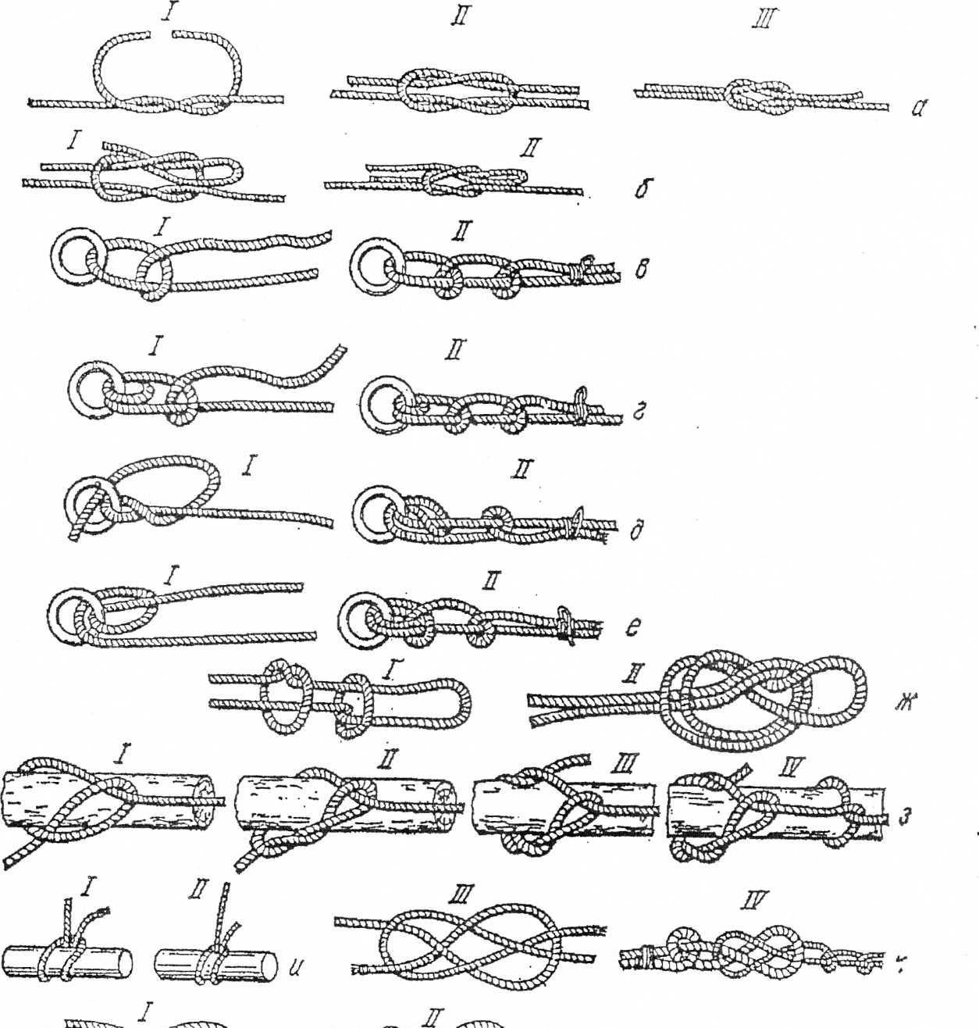

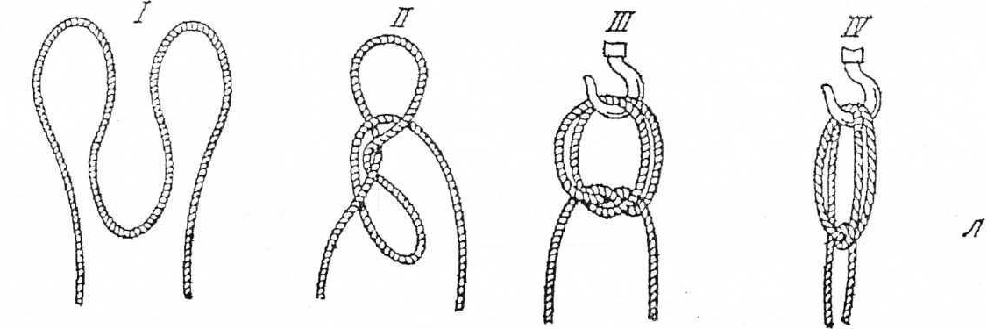
a – straight; b – reef; c – simple bayonet; d – bayonet with two hoses;
d – bayonet with a handle; e – bayonet with two hoses and a cover; well - marine
(with a non-tightening loop); c – carpenter's knot (bottle); and is a dead loop;
k – flat node; l – loops for reducing the length of slings; (I–IV– the sequence of the knot tie positions).
Appendix B

Recommended sign signaling used during
moving cargo with cranes
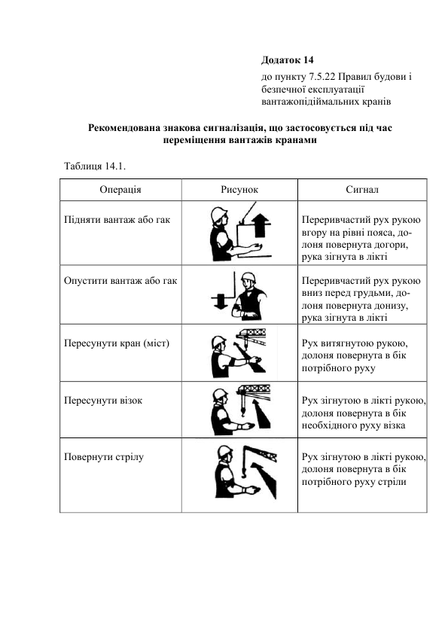

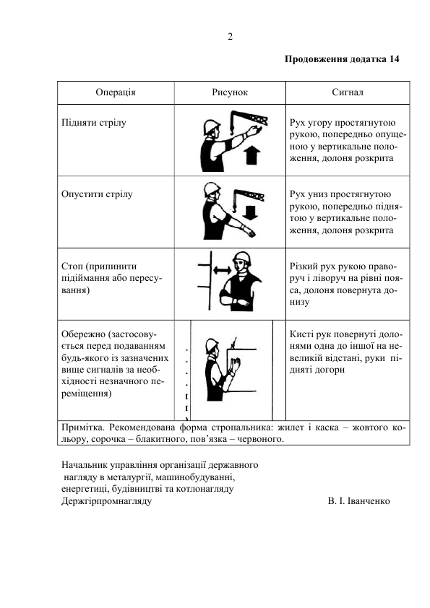

Appendix B

I N S T R U C T I O N
ON THE OVERVIEW OF REMOVABLE CARGO GRIPPERS AND CONTAINERS

1. General provisions
1.1. The business entity that operates lifting cranes and machines, removable load-handling devices and containers ensures their maintenance in good condition and safe operation by organizing proper departmental supervision, maintenance, technical inspection and repair.
1.2. Detachable load-handling devices (slings, clamps, grabs, traverses, grapples, electromagnets, etc.) and their components must meet the requirements of regulatory documents (ND), and their design must exclude the possibility of arbitrary disconnection of the load.
1.3. The calculation of slings made of materials approved for these purposes is carried out taking into account the number of strands of ropes and the angle of their inclination to the vertical. The permissible working load on the sling is determined under the condition of uniform tension of each of the branches and compliance with the calculated angle of 45 ° between the branch and the vertical. It is allowed to assign an additional working load to the sling for an angle of inclination of the branch up to 60 ° from the vertical. For a sling with more than three strands, which perceive the calculated load, no more than three strands are taken into account in the calculation. During the calculation of slings intended for the transportation of a known load in advance, the actual angles can be taken as the calculated angles between the line of the sling and the vertical.
1.4. For rope slings made of steel ropes, steel ropes with a cross twist must be used in accordance with the requirements of ND. The reserve factor of the breaking force of the rope in relation to the load of a single strand of the sling must be at least 6.
1.5. The ends of the ropes of the slings are trimmed by pressing with aluminum bushings, crimping with steel bushings or braiding. The number of punctures of the main branch of the rope with each full table during braiding should correspond to the ones indicated in the table:

Diameter of steel rope, mm | The number of punctures in each full  a table, no less
Until 14 inclusive  Over 14 - 27  Over 27 - 60 | 4  5  6

1.6. The last puncture with each needle is performed with half the number of its wires (half the cross-section of the needle). It is allowed to make the last puncture with half the number of rope stands. Places of entanglement with the protruding ends of the wires of the tables by 10-30 mm in both directions, depending on the diameter of the rope, must be tightly wrapped with a soft wire, the ends of which are tucked in a way that makes it impossible to unwind them, or isolated in another way that makes it impossible to damage the workers' hands.
1.7. For chain slings, round-link chains must be used in accordance with the requirements of ND. The reserve factor of the destructive load of the chain relative to the load of a single branch of the sling must be at least 4.
1.8. Hemp, cotton, sisal ropes used for the manufacture of slings must meet the requirements of ND. The possibility of using ropes made of synthetic materials (polyamide, polypropylene, polyester) and combined, as well as tapes, for the production of slings is established by technical conditions. The coefficient of reserve of breaking force relative to the load of a single line of the sling should be at least 7 for ropes and tapes made of synthetic materials, and at least 8 for ropes made of natural fibers.
1.9. Braiding a loop of hemp, cotton, sisal rope should have at least two full and two half punches. The place of braiding must be wrapped with a rope or protected in another way.
1.10. For removable motorized grapples or other load-grabbing devices, the rotation of which in the vertical plane during operation is not permissible, the fixation of the load-grabbing device relative to the body of the hook suspension must be ensured.
1.11. Detachable load-handling devices (slings, traverses, clamps, grabbers, etc.) after manufacture are subject to acceptance tests by the manufacturer, and after repair - by the company where they were repaired, according to the program and test methodology developed by the manufacturer, repair company or other organization.
1.12. Containers for small, loose and other cargoes are inspected and tested after manufacture in accordance with the requirements of ND, including static and dynamic testing of containers with a load evenly distributed on the bottom, which exceeds the gross weight of the container by 10%, by lifting it by two diagonally located sling elements.
1.13. Detachable load-handling devices must have a stamp or a firmly attached tag indicating the name of the manufacturer or its trademark, load capacity, serial number according to the manufacturer's numbering, test date and other information in accordance with the requirements of the technical conditions for a specific product. Detachable load-handling devices manufactured for third-party organizations, except for a stamp (tag), must be equipped with a passport of the established model.
1.14. The container must have a stamp or a firmly attached tag (plate) indicating the name of the manufacturer or its trademark, the conventional designation, the weight of the container, the gross weight, the date of manufacture and the serial number according to the numbering of the manufacturer.
1.15. Detachable load-handling devices and containers are equipped with an individual number and are recorded under this number in their accounting journal of the enterprise or division.

2. The procedure for inspecting removable load-handling devices and containers
2.1. During operation, removable load-handling devices and containers are subject to periodic inspection in the following terms:
- slings - every 10 days;
– electromagnets, grapples – monthly;
– traverses, tongs, grabs, etc., as well as containers – monthly;
- removable load-handling devices that are rarely used - before each commissioning.
Classification of load-handling devices as rarely used is carried out by the employee responsible for maintaining them in good condition, and must be recorded in the record book of these devices.
2.2. Slingers, before using removable load-handling devices and containers, inspect them in accordance with the requirements of the ND and this instruction.
2.3. Damaged removable load-handling devices, containers and cradles for lifting workers detected during the inspection are taken out of service for repair or discarded. The results of the inspection are entered in the record book of load-handling devices and containers.
2.4. The scrapping of removable load-handling devices in operation must be carried out in accordance with the ND, which determine the procedure, methods of scrapping and scrapping indicators, as well as the requirements of this instruction.
2.5. Slings are subject to failure in the following cases:
a) rope steel sling is also subject to rejection in the following cases:
- if the stamp (tag) is missing or damaged;
- if there are no safety locks on the hooks;
- in the case of deformation of the couches or their wear with a reduction in cross-sectional dimensions of more than 15%;
- in case of detection of one or more broken tables in the rope;
- if there are signs of the rope shifting in the braid or bushings;
- if the number of visible breaks in the outer wires of the rope exceeds that specified in the table:

Rope slings  double twist | The number of visible wire breaks in the area  rope sling length
Rope slings  double twist | 3d | 6d | 30d
Rope slings  double twist | 4 | 6 | 16
Note: d is the diameter of the rope, mm.

- in the case of a decrease in the diameter of the rope as a result of deterioration of the core - internal surface failure, crumpling, tearing, etc. by 3% of the nominal diameter in ropes that do not unwind, and by 10% in other ropes (even in the absence of visible wire breaks);
- in the case of a decrease in the diameter of the rope as a result of surface corrosion or corrosion by 7% or more compared to the nominal diameter of the rope (even in the absence of visible breaks in the wires).
- in case of detection of the following types of deformation: basket-shaped deformation (Fig. 1.1), extrusion of the metal core (Fig. 1.2), extrusion of the wires of the stands (Fig. 1.3), local increase in the diameter of the rope (Fig. 1.4), local decrease in the diameter of the rope (Fig. 1.5), crushed areas (Fig. 1.6), twists (Fig. 1.7), kinks (Fig. 1.8), bends (Fig. 1.9), damage as a result of thermal effects or electric arc discharge.

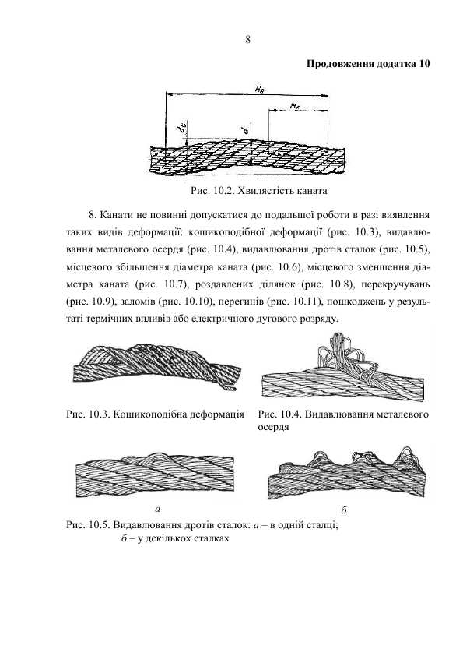
Fig. 1.1. Basket-like deformation | Fig. 1.2. Extrusion of the metal core
Fig. 1.3. Extrusion of wires of tables: a – in one table; b - in several tables
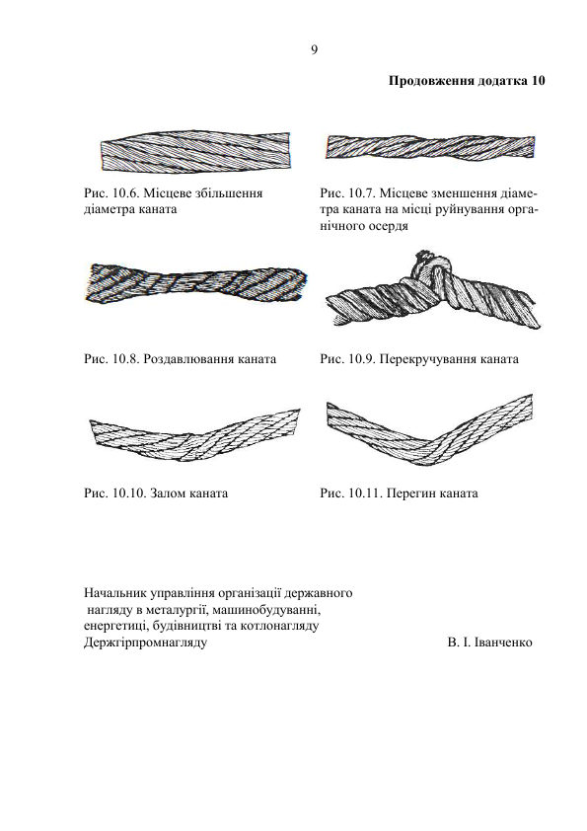
Fig. 1.4. Local increase in rope diameter | Fig. 1.5. Local reduction of the diameter of the rope at the point of destruction of the organic core
Fig. 1.6. Crushing the rope | Fig. 1.7. Twisting the rope
Fig. 1.8. Rope break | Fig. 1.9. A bend in the rope

c) the chain sling is subject to failure in the following cases:
- if the stamp (tag) is missing or damaged;
- if there are no safety locks on the hooks;
- in case of malfunction of the end elements (presence of cracks, wear of the surface of the elements or local dents, which lead to a reduction of the cross-sectional area by more than 10%);
- if there is a crack in the chain links;
- in the case of lengthening of the chain link by more than 3% of the original size (Fig. 3.1) and in the case of a decrease in the cross-sectional diameter of the chain link by more than 10% due to activation (Fig. 3.2).

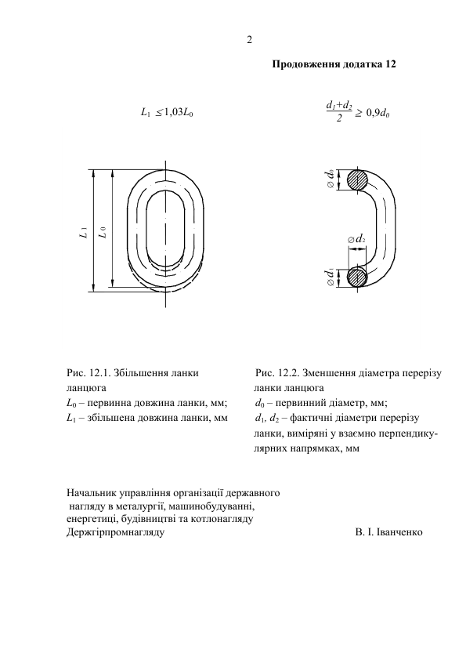

Fig. 3.1. Increasing the chain link, where:  L0 – primary link length, mm;  L1 – increased link length, mm | Fig. 3.2. Reduction of the cross-sectional diameter of the chain link, where:  d0 – primary diameter, mm;  d1, d2 – actual cross-sectional diameters of the link, measured in mutually perpendicular directions, mm

2.6. Tara is eliminated in the following cases:
- in the absence or violation of labeling;
- in the presence of significant deformations;
- in the presence of cracks in welds or main structures;
- in case of damage to hinges or other devices for engagement;
- in case of failure of locking or fixing devices;
- when the eyelets are worn by 10% or more from the initial diameter.
2.7. load-handling devices (clamps, traverses, grabs), in which it is impossible to determine the technical condition of the elements in assembled form, are subject to partial disassembly, inspection and revision every year.
2.8. Detachable load-handling devices and containers that have not passed a periodic inspection are not allowed to work. Rejected removable load-handling devices and containers, as well as those without labels (stamps), should not be in the work areas.

Appendix G

INSTRUCTION

on the safe conduct of work for slingers (hookers) who perform work with load-lifting cranes
1. General provisions

1.1. This Instruction was developed on the basis of NPAOP 0.00-1.80-18 "Rules for occupational health and safety during the operation of load-lifting cranes, lifting devices and related equipment" (hereinafter - the Rules).
1.2. At each site of work of lifting cranes, for tying, hooking or hanging loads, the business entity must appoint slingers from among employees who have reached the age of 18 and have undergone training in the prescribed manner.
1.3. At industrial enterprises, workers of basic professions, additionally trained in a shortened program of a slinger, may be allowed to hang loads on the hook of a crane without prior duty (loads that have hinges, rimbolts, trunnions, as well as those in buckets, buckets, containers or other containers) or when loads are captured by semi-automatic gripping devices. These workers are subject to the same requirements as slingers.
1.4. Before the slingers are allowed to work, a knowledge test of regulatory legal acts on occupational health and safety is carried out in accordance with the procedure established by the Standard Regulation on the procedure for conducting training and testing knowledge on occupational health and safety issues.
1.5. The number of slingers serving one crane is determined by the business entity. When appointing two or more slingers, one of them is appointed senior.
1.6. In cases where the area served by the crane is not completely visible from the cabin of the crane operator, a signalman from among the certified slingers is appointed to transmit the signals of the slinger to the crane operator by the employee responsible for the safe performance of work with load-lifting cranes.
1.7. The slinger in his work is subordinate to the person responsible for the safe carrying out of work on the movement of loads by cranes.
1.8. A slinger allowed to work independently must:
a) have a concept of the construction of the crane he serves and know its load capacity; slingers who service jib self-propelled cranes must be able to determine their load capacity depending on the boom departure and the position of additional supports;
b) be able to select slings necessary for work (in terms of load capacity, number of strands, length and angle of inclination of sling strands to the vertical) and other load-handling devices depending on the mass and nature of the cargo being moved;
c) be able to determine the suitability of slings and other removable load-handling devices and containers;
d) be able to carry out the correct duty and hanging of cargo on a hook;
e) know the rules for filling containers;
e) to know and apply in work the order of sending signals to the crane operator established at the enterprise;
f) know the order and dimensions of cargo storage;
g) know the procedure for safely carrying out work with jib self-propelled cranes near power lines;
h) to know the procedure for releasing persons who have been exposed to electric current, methods of providing them with first aid;
i) know this Standard Instruction.
1.9. The slinger must know the location of the circuit breaker through which voltage is supplied to the main trolley wires or the flexible cable that feeds the electric crane, and be able to disconnect the crane from the electrical network in necessary cases.

2. Duties of slingers before starting work

2.1. Before starting work, the slinger must:
a) select load-handling devices corresponding to the weight and nature of the load being lifted; slings should be selected taking into account the number of strands and length, so that the angle between the strands does not exceed 90 degrees. WITH;
b) to check the serviceability of load-handling devices and containers, the presence of stamps or tags on them indicating the number, date of manufacture and load capacity, as well as the presence of an inscription on the container about its purpose and own weight;
c) check the lighting of the workplace; in case of insufficient lighting, the slinger, without starting work, must report this to the employee responsible for the safe performance of work with load-lifting cranes.

3. Responsibilities of slingers when tying and hitching loads

3.1. The slinger can start work only after receiving the task, and in the case of its ambiguity - after receiving instructions from the employee responsible for the safe performance of work with lifting cranes.
3.2. When tying and hooking the load, the slinger must be guided by the following instructions:
a) strapping or hitching of cargo should be carried out in accordance with cargo slinging schemes; slinging of loads that are rarely lifted and for which slinging schemes have not been developed, should be carried out under the guidance of an employee responsible for the safe performance of work with load-lifting cranes;
b) check the weight of the cargo, which is intended to be moved by the crane, according to the list of cargo or according to the marking on the cargo; if the slinger does not have the opportunity to determine the mass of the load, then he must find out it from the employee responsible for the safe performance of work with load-lifting cranes;
c) when tying the cargo, ropes and chains must be placed on the main body of it (frame, frame, body, bed) without knots and loops; special pads should be placed under the sharp edges (ribs) of the loads, which protect the slings from damage;
d) the load must be tied in such a way that during its movement the fall of its individual parts (boards, logs, rods) is excluded and the stable position of the load is ensured during movement; for this, long loads must be lashed in at least two places;
e) hooking of reinforced concrete products, as well as other loads that have hinges, rims, pins, should be carried out using all the hinges, rims, pins provided for lifting in the appropriate position;
e) when hanging the load on two-horn hooks, the slings must be applied in such a way that the load is distributed evenly on both horns;
f) fix the ends of multi-turn slings not used for hooking the load in such a way that when moving the load with a crane, the possibility of these ends touching objects encountered on the way is excluded;
g) when lifting the load with two cranes, slinging and hanging the load must be carried out under the direct supervision of the employee responsible for the safe performance of work with load-lifting cranes;
h) make sure that the load intended for lifting is not secured by anything, is not pinched, is not collapsed and is not frozen to the ground.
3.3. When tying and hooking loads, the slinger is prohibited from:
a) carry out slinging of cargo, the weight of which he does not know or when the weight of the cargo exceeds the load capacity of the crane;
b) use damaged or unmarked load-handling devices and containers; connect links of broken chains with bolts or wire, tie ropes;
c) carry out tying and hitching of loads in other ways than indicated on the slinging diagrams;
d) use devices that are not provided for by slinging schemes (crows, pins, etc.) for tying and hooking loads;
e) carry out the movement of pallets with bricks without a fence, excluding the loading and unloading (on the ground) of cars, as well as on the condition that people move away from the area of ​​movement of goods;
e) engage concrete and reinforced concrete products that do not have markings, as well as engage these products by damaged hinges;
f) hang the load by one corner of a double hook;
g) strapping or hooking the load to the crane hook at a distance closer than 40 m from the end wire of the power transmission line with a voltage of more than 42 V without issuing a permit and the presence of an employee responsible for the safe performance of work with load-lifting cranes, appointed by order of the enterprise, whose name is indicated in the permit;
h) drive the hook of the sling into the mounting loops of reinforced concrete products and other loads that have mounting loops;
i) correct the branches of the slings in the mouth of the hook by hitting them with heavy objects;
i) correct the sling on the load being lifted by hitting it with a hammer or other objects;
i) use attachment ladders when tying large wall blocks and other high loads; in these cases, portable platforms should be used;
j) use the grapple for lifting people and loads for which it is not intended, for hanging loads with the help of slings on the jaws of the grapple, as well as for performing work for which the grapple is not intended.

4. Responsibilities of slingers when lifting and moving cargo

4.1. Before carrying out each operation on lifting and moving the load, the slinger must personally give the appropriate signal (by gesture, and with a boom length of up to 10 m - by voice) to the crane operator or signalman, and when servicing one crane by several slingers, the signal is given by the senior slinger.
4.2. Before giving the signal to lift the load, the slinger must:
a) make sure that the cargo is securely strapped and not held back by anything;
b) check whether there are no loose parts and tools on the cargo; when lifting large-diameter pipes, check that there is no earth, ice, or other objects in them that may fall out during lifting and moving;
c) make sure that the load cannot catch on anything during lifting;
d) make sure there are no people near the load, between the load being lifted and walls, columns, stacks, machines and other equipment.
Before lifting a load with a jib crane, the slinger must also check that there are no people near the crane itself, on its non-rotating platform, in the boom lowering zone, the load and to get out of the danger zone himself.
4.3. When lifting and moving the load, the slinger must:
a) give a signal to raise the load to a height of 200-300 mm, check the correctness of its slinging, the uniformity of the tension of the slings, the stability of the crane, the operation of the brakes, and only after that give the signal to raise the load to the required height; if it is necessary to correct the slinging, the load must be lowered to the ground;
b) when removing the load from the foundation bolts, ensure that the lifting is carried out at the lowest speed, without distortions, jamming and horizontal movement of the load until it is completely removed from the bolts;
c) check on the load capacity indicator, before lifting the load with jib self-propelled cranes, that the jib boom set by the crane operator corresponds to the weight of the load being lifted;
d) before moving the load horizontally, make sure that it is raised to a height of at least 500 mm above the objects on the way;
e) accompany the cargo during movement and ensure that it does not move over people and cannot catch on anything; if it is not possible to accompany the load, the crane operator must monitor its movement, and if the load is in an area that cannot be seen from the crane operator's cabin, the second slinger or signalman must monitor it;
f) to prevent arbitrary turning of long and bulky loads during their lifting or moving, use special braces;
g) stacking of cargo is carried out evenly, without violating the dimensions established for storage and without cluttering passages and passageways, so that the distance from the protruding elements of the rotating part of the jib self-propelled crane (vehicle, crawler, railway, pneumatic wheel) to the cargo is at least 1 m, and from the protruding elements of the tower, gantry and gantry crane - at least 0.7 m; if it is impossible to comply with this condition, the work must be stopped; placing the cargo in wagons, semi-wagons and on platforms, as well as removing it, should not cause a disturbance in the balance of the indicated vehicles, the vehicles themselves are reinforced to prevent their arbitrary movement;
g) bulk and small cargoes should be lifted in a specially designated container; at the same time, it is not allowed to fill the container above the established norm.
4.4. When lifting and moving loads, the slinger is prohibited from:
a) to be on the cargo during lifting or moving, as well as to allow the lifting or moving of the cargo, if there are people on it;
b) to be under the lifted load or allow other people to be under it;
c) pull the load during its lifting, moving, or lowering;
d) to be alone and allow people to stay on the railway platform, in a semi-car, car body when carrying out loading and unloading operations with grapples or magnetic cranes;
e) use cranes to release pinched removable load-handling devices.
4.5. When operating self-propelled jib cranes near power lines, the slinger must be especially careful.
To prevent electric shock, the slinger, before each operation that requires contact with the load, slings, hook or elements of the crane, must certify that the boom of the crane or the ropes are not dangerously close to the wires of the power transmission line.
4.6. During operation of jib self-propelled and tower cranes, in order to prevent pinching between the rotating and non-rotating parts of the crane, the slinger should not be in dangerous places.
4.7. If the slinger notices a malfunction of the crane, under-crane track or other danger while moving the load, he must immediately give a signal to stop moving the load and report the malfunction to the crane operator.

5. Responsibilities of slingers when lowering cargo

5.1. Before lowering the load, the slinger must:
a) inspect in advance the place where the load will be lowered and make sure that it cannot fall, overturn or slide;
b) at the place of installation of the load, if necessary, put strong pads in advance for the convenience of pulling out the slings from under it;
c) remove the slings from the load or the hook only after the load is securely installed and, if necessary, secured.
5.2. The slinger is prohibited from placing the load on temporary ceilings, pipes, cables and other places not intended for placing the load.

6. Responsibility of slingers

6.1. The slinger is responsible in accordance with the current legislation of Ukraine.

